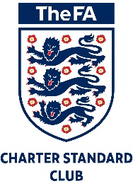
Play Your Part
(Code of Conduct)

Young Players
We all have a responsibility to promote high standards of behaviour in the game. As a player, you have a big part to play. That’s why The FA is asking every player to follow a Respect Code of Conduct.
When playing football, I will;
- Always play to the best of my ability
- Play fairly – I won’t cheat, complain or waste time
- Respect my team-mates, the other team, the referee/match officials or my coach/manager
- Play by the rules, as directed by the referee
- Shake hands with the other team and referee at the end of the game
- Listen and respond to what my coach or team manager tells me & understand that they have to do what’s best for the team
- Talk to someone I trust or the club welfare officer if I’m unhappy about anything at my club
- Respect the facilities home and away

I understand that if I do not follow the Code, any or all of the following actions may be taken by my club, County FA or The FA:
I may:
- Be required to apologise to my team-mates, the other team, referee or team manager
- Receive a formal warning from the coach or the club committee
- Be dropped or substituted
- Be suspended from training
- Be required to leave the club

In addition:
- My club, County FA or The FA may make my parent or carer aware if you have not followed any of the Code of Conduct
- The FA/County FA could impose a fine and suspension against my club

www.thefa.com/respect
www.thefa.com/Footballsafe

Review
This statement will be reviewed by the Executive Committee Team each year, or sooner where new developments in guidance and legislation necessitate such a review, where factual clarification is required or changes to operational practices take place.

Reviewed October 2020

Next Review Date: September 2021

Signed (Chairman): Date:

